**Question1**

**Create a function that takes an integer and returns a list from 1 to the given number, where:**

1. **If the number can be divided evenly by 4, amplify it by 10 (i.e. return 10 times the number).**
2. **If the number cannot be divided evenly by 4, simply return the number.**

**Examples**

**amplify(4) ➞ [1, 2, 3, 40]**

**amplify(3) ➞ [1, 2, 3]**

**amplify(25) ➞ [1, 2, 3, 40, 5, 6, 7, 80, 9, 10, 11, 120, 13, 14, 15, 160, 17, 18, 19, 200, 21, 22, 23, 240, 25]**

**Notes**

* **The given integer will always be equal to or greater than 1.**
* **Include the number (see example above).**
* **To perform this problem with its intended purpose, try doing it with list comprehensions. If that's too difficult, just solve the challenge any way you can.**

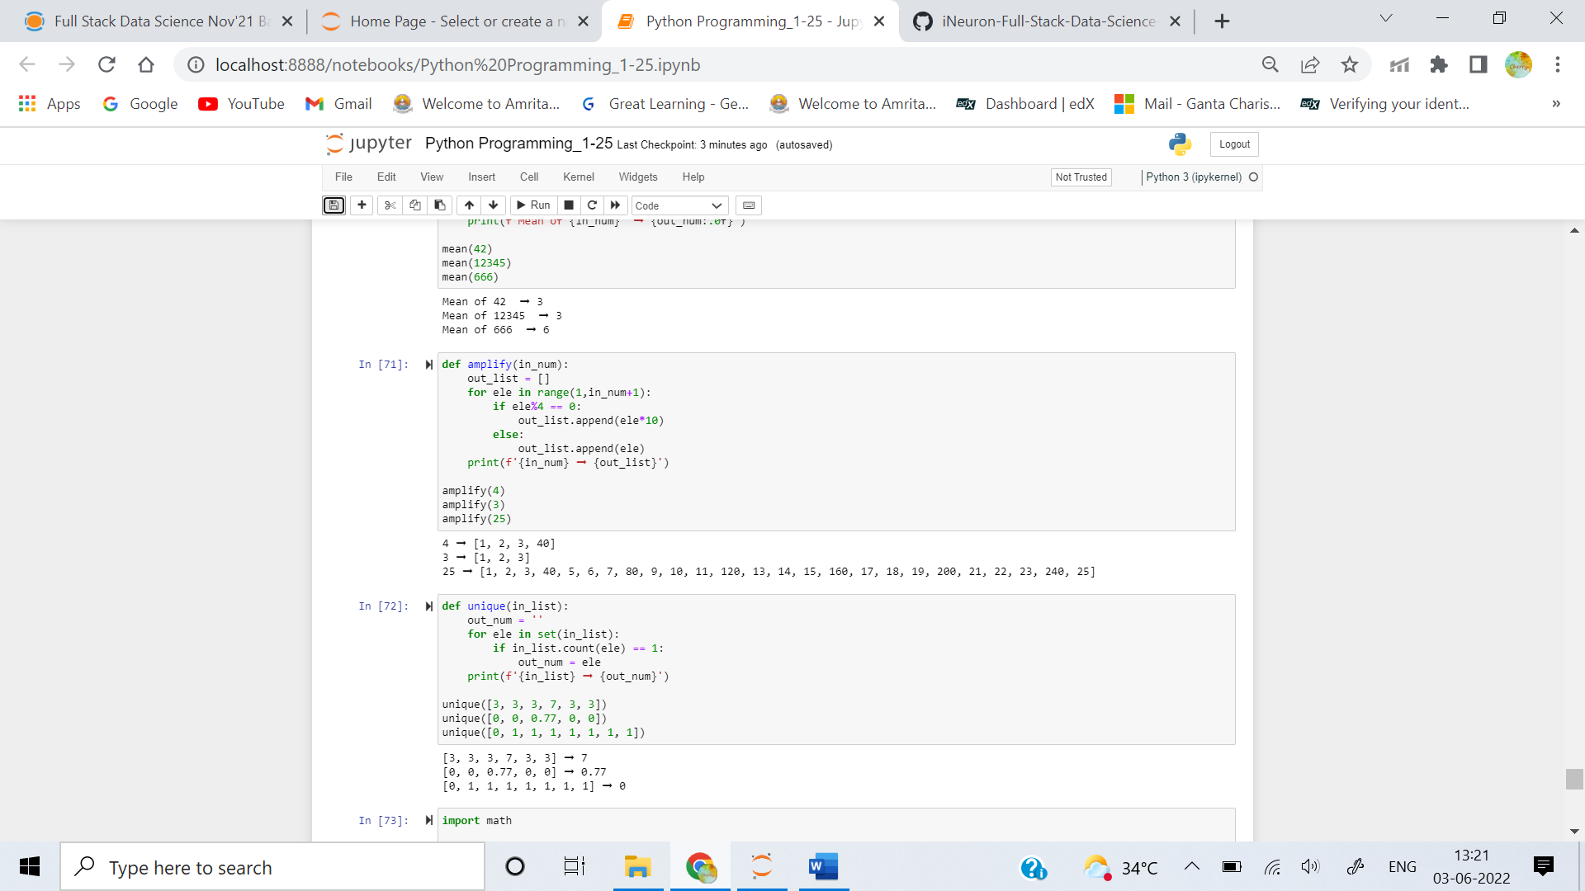

**Question2**

**Create a function that takes a list of numbers and return the number that's unique.**

### Examples

**unique([3, 3, 3, 7, 3, 3]) ➞ 7**

**unique([0, 0, 0.77, 0, 0]) ➞ 0.77**

**unique([0, 1, 1, 1, 1, 1, 1, 1]) ➞ 0**

### Notes

**Test cases will always have exactly one unique number while all others are the same.**



**Question3**

**Your task is to create a Circle constructor that creates a circle with a radius provided by an argument. The circles constructed must have two getters getArea() (PIr^2) and *getPerimeter()* (2PI*r) which give both respective areas and perimeter (circumference).**

**For help with this class, I have provided you with a Rectangle constructor which you can use as a base example.**

### Examples

**circy = Circle(11)**

**circy.getArea()**

**# Should return 380.132711084365**

**circy = Circle(4.44)**

**circy.getPerimeter()**

**# Should return 27.897342763877365**

### Notes

**Round results up to the nearest integer.**

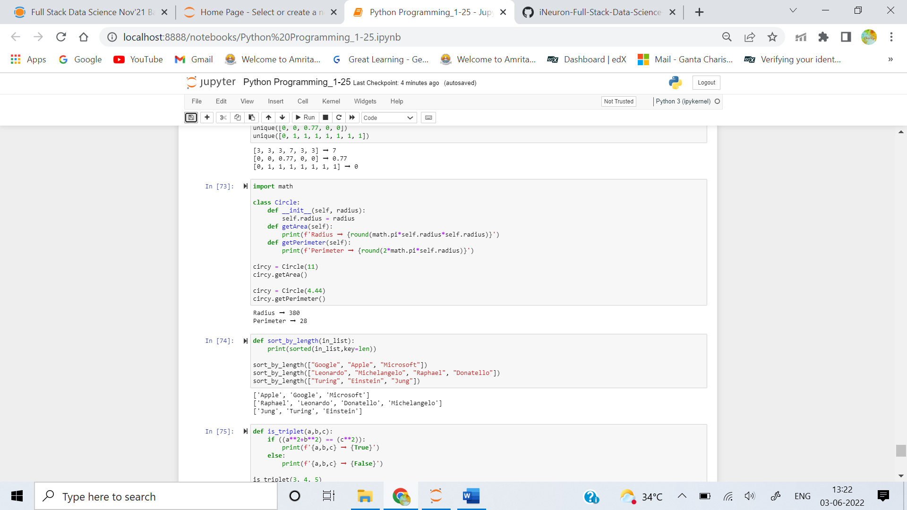

**Question4**

**Create a function that takes a list of strings and return a list, sorted from shortest to longest.**

### Examples

**sort_by_length(["Google", "Apple", "Microsoft"])**

**➞ ["Apple", "Google", "Microsoft"]**

**sort_by_length(["Leonardo", "Michelangelo", "Raphael", "Donatello"])**

**➞ ["Raphael", "Leonardo", "Donatello", "Michelangelo"]**

**sort_by_length(["Turing", "Einstein", "Jung"])**

**➞ ["Jung", "Turing", "Einstein"]**

### Notes

**All test cases contain lists with strings of different lengths, so you won't have to deal with multiple strings of the same length.**



**Question5**

**Create a function that validates whether three given integers form a Pythagorean triplet. The sum of the squares of the two smallest integers must equal the square of the largest number to be validated.**

### Examples

**is_triplet(3, 4, 5) ➞ True**

**# 3² + 4² = 25**

**# 5² = 25**

**is_triplet(13, 5, 12) ➞ True**

**# 5² + 12² = 169**

**# 13² = 169**

**is_triplet(1, 2, 3) ➞ False**

**# 1² + 2² = 5**

**# 3² = 9**

### Notes

**Numbers may not be given in a sorted order.**

